Install GitLab CE on Ubuntu 20.04
GitLab is an open-source DevOps platform which provides Git repositories management, continuous integration, issue tracking, and other features. Self-managed GitLab can be installed on own server.
This tutorial explains how to install GitLab Community Edition (CE) on Ubuntu 20.04.

Prepare environment
Run the following command to update the package lists:

1 | sudo apt update

Make sure you have installed OpenSSH server:

1 | sudo apt install -y openssh-server

Install GitLab CE
Add the GitLab CE package repository:

1 | wget -qO - https://packages.gitlab.com/install/repositories/gitlab/gitlab-ce/script.deb.sh | sudo bash

Install the GitLab CE:

1 | sudo apt install -y gitlab-ce

When installation is completed, we can check GitLab CE version:

1 | grep gitlab /opt/gitlab/version-manifest.txt

Now we need to set URL which will be used to access GitLab instance. It can be done in configuration file:

1 | sudo nano /etc/gitlab/gitlab.rb

Find external_url parameter and set IP address or hostname of your machine. Default port is 80, but you can explicitly set if needed.

1 | external_url 'http://192.168.0.188:9000'

To make changes to take effect, reconfigure the GitLab:

1 | sudo gitlab-ctl reconfigure

When it finished, we can check the status of GitLab services:

1 | sudo gitlab-ctl status

We can also stop, start and restart the GitLab services:

1  2  3 | sudo gitlab-ctl stop  sudo gitlab-ctl start  sudo gitlab-ctl restart

Testing GitLab CE
By default, random password is generated during installation. Password can be found in the following file:

1 | sudo cat /etc/gitlab/initial_root_password

Now open the browser and enter IP address or hostname to access the GitLab web interface. Use username root and password from a file to login.
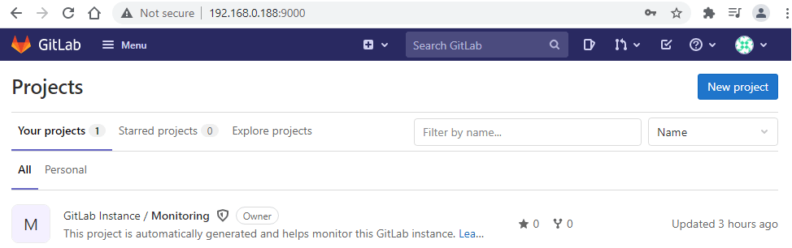
Password can be changed in user settings page:

1 | <GITLAB_URL>/-/profile/password/edit

Uninstall GitLab CE
If you want to completely remove GitLab CE, execute the following command:

1 | sudo apt purge --autoremove -y gitlab-ce

When it finished, remove systemd service:

1  2  3  4  5 | sudo service gitlab-runsvdir stop  sudo systemctl disable gitlab-runsvdir  sudo rm -rf /usr/lib/systemd/system/gitlab-runsvdir.service  sudo systemctl daemon-reload  sudo systemctl reset-failed

Remove GPG key and repository:

1  2 | sudo apt-key del 51312F3F  sudo rm -rf /etc/apt/sources.list.d/gitlab_gitlab-ce.list

Remove GitLab users:

1  2  3  4  5 | sudo deluser gitlab-www  sudo deluser gitlab-redis  sudo deluser gitlab-psql  sudo deluser gitlab-prometheus  sudo deluser git

You can also remove GitLab configuration, logs, data, and other related directories:

1  2  3  4  5  6 | sudo rm -rf /etc/gitlab  sudo rm -rf /var/log/gitlab  sudo rm -rf /var/opt/gitlab  sudo rm -rf /run/gitlab  sudo rm -rf /opt/gitlab  sudo rm -rf /usr/bin/gitlab-redis-cli

